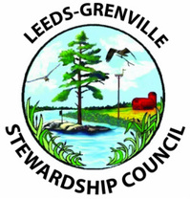

Garnet Baker Memorial Bursary

Leeds Grenville Stewardship Council will continue to make available two (2) $1000 bursaries for Leeds and Grenville students who will be attending post-secondary education this fall, however it will now be called the Garnet Baker Memorial Bursary in honour of Garnet Baker, a founding member and dedicated volunteer of our council.

The applicants must be full time high school students in the United Counties of Leeds and Grenville.

Graduating students who plan to further their studies in any field of Environmental Studies (forestry, wildlife studies, geography, agricultural science, etc.) are eligible to apply.

The award winners will be selected by a committee of LGSC members based on Financial need, Community service, and
Academic record.

The winners will be notified in time for Graduation ceremonies this year.

APPLICANTS ARE TO SUBMIT OR EMAIL THEIR COMPLETED APPLICATION PACKAGES TO MR. CROSS ON OR BEFORE APRIL 20. HE WILL EMAIL YOUR APPLICATION PACKAGE ON YOUR BEHALF.

YOUR APPLICATION PACKAGE MUST INCLUDE 3 THINGS:
(1) Your resume.
(2) A letter describing your plans for post-secondary education and why you feel you deserve the bursary.
(3) An Academic Transcript must also accompany the resume and letter. Mr. Cross will get this for you and include it in the package he sends to the LGSC on your behalf.

